Model 2001-CSXX

Power Monitor Module

Operation Manual
Congratulations on your purchase, and welcome to Prodigit 2001-CSXX power monitor module. This operation manual will guide you step by step for the various functions of the Power Monitor.

Warning:
- To prevent fire or shock hazard, do not expose the unit to rain or moisture.
- The 2001-CS1X’s operating voltage is limited to 90~132Vrms 50/60Hz and the 2001-CS2X’s operating voltage is limited to 187~264Vrms 50/60Hz, Don't use it in other voltage ratings.
- Indoor use only.
- The maximum output current is 12/16/24A(This value can setting).The buzzer whistles and the reading on the LCD display flashes when over current.
- To avoid electrical shock, do not open the cabinet. Refer servicing to qualified personnel only.

- Installation: (Figure 1)
2001-CSXX include 8 precision digital Meter. Plug the 2001-CSXX to wall outlet, then connects the appliance or equipment to its receptacle, the LCD display will be lit after power up.
- The LCD shows all Volt, Current, Watt, Frequency, Power Factor, VA, KWH and elapsed time (hour) readings.
- Press the Volt key can select the volt mode on display.
- Press the Amp key can select the Amp mode on display.
- Press the Watt/VA key can select the Watt and VA mode on display.
- Press the HZ/PF key can select the Frequency and Power Factor value mode on display.
- Press the KWH can select the KWH and Elapsed time mode on display.
- Hole the Volt key 3 second can into Over Current Setting, the mode can select 15A/20A/30A Setting. The buzzer whistles when the current is over 15A/20A/30A * 80%.

MAINTENANCE
- Protect the meter from adverse weather conditions. The meter is not waterproof. Do not expose the LCD display to direct sunlight for long periods of time.
- CAUTION: To avoid damage to the meter, do not expose it to sprays, liquids, or solvents.
- Clean the exterior of the meter by removing dust with a lint-free cloth.
- Use care to avoid scratching the clear plastic display filter.
- For further cleaning, use a soft cloth or paper towel dampened with water. You can use a 75% isopropyl alcohol solution for more efficient cleaning.
- CAUTION: To avoid damage to the surface of the meter, do not use abrasive or chemical cleaning agents.

Specifications:
The Specification is base on sine wave & P.F.=1
Model 2001-CSXX
ITEM | 2001-CS1X |  | 2001-CS2X
RMS voltage | 90～132 Vrms |  | 187~264 Vrms
RMS current | 0.2～30.0 Arms |  | 0.2~30.0 Arms
Active power | 18～3960 Watts |  | 36~7920 Watt
Apparent power | 18～3960 VA |  | 36~7920 VA
Line Frequency | 47.0~63.0 Hz
Power Factor | 0.00～1.00
KWH | 0.00～9999 KWH
Elapsed Time | 00:00～9999
Accuracy
ITEM |  | Max. |  | Typ.
RMS voltage |  | 1% |  | 0.2%
RMS current |  | 1% |  | 0.3%
Active power |  | 2% |  | 0.5%
Apparent power |  | 2% |  | 0.5%
Line Frequency |  | 2% |  | ±0.1Hz
Power Factor |  | 0.03 |  | ±0.01
KWH |  | 2% |  | 0.5%
Elapsed Time |  | 30 ppm
Note:
1、The typical accuracy for voltage is in the range of 108V～132V(2001-CS1X, and for current is in the range of 0.2A～30A.
2、The typical accuracy for voltage is in the range of 187V～264V(2001-CS2X, and for current is in the range of 0.2A～30A.

Outward Size:

Model | SIZE (L×W×H)
Model 2001-CSXH | 125mm×37.5mm×33mm
Model 2001-CSXV | 37.5mm×125mm×30mm

Environment Condition:
- Altitude up to 2000m
- Operation temperature 5℃～40℃
- Max. R.H. 80%
- CAT Ⅱ
- Pollution degree 2

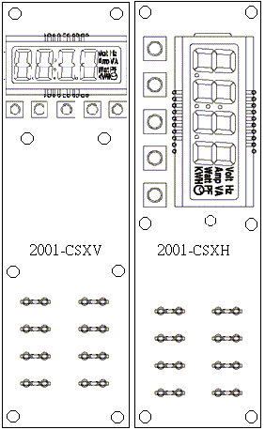
Figure 1：2001-CSXX surface diagram

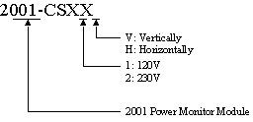

Figure 2 ：Type Description diagram

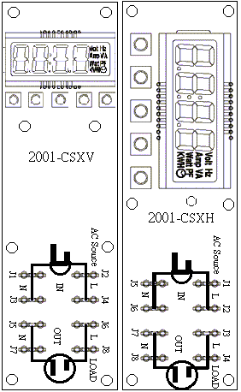
Figure1:2001-CSXX Installation diagram
Figure 3 ：2001-CSXX Wiring Diagram

